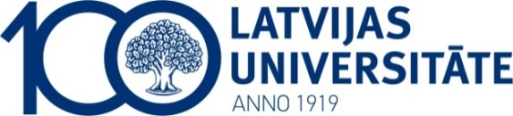
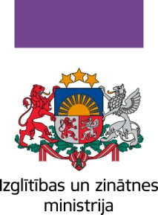
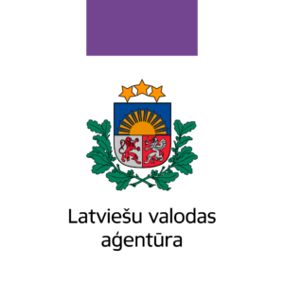
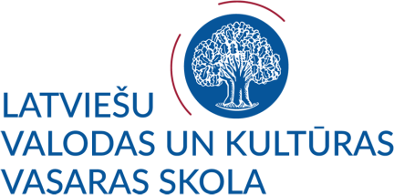

SUMMER SCHOOL OF LATVIAN LANGUAGE AND CULTURE 2019 FOR DIASPORA YOUTH

PROGRAM*
Riga
July 03 – July 16, 2019

July 03, Thursday
- registration
- Latvian language class
- welcome meeting

July 04, Wednesday
- excursion around Riga and its suburbs (in English and Latvian)
- Latvian language class

July 05, Friday
- Latvian language and literature class in Rainis and Aspazija House-Museum in Rīga
- excursion to the National Library (in English and Latvian)
July 06, Saturday
- Latvian language class
- excursion to the Museum of the History
of Riga and Navigation/Museum of the
Occupation of Latvia (in English and Latvian)

July 07, Sunday
- activities/free time (e.g. trip to Sigulda, Jūrmala)

July 08, Monday
- Latvian language class
- lecture on Latvian history and politics (in Latvian with simultaneous translation into English)

July 09, Tuesday
- Latvian language class
- departure to Ventspils by bus
- dinner in Ventspils
- free time

July 10, Thursday
- breakfast
- Latvian language class
- Latvian language learning activities at Ventspils House of Crafts
- excursion to Kuldiga
- return to Riga

July 11, Wednesday
- Latvian language and folklore
- lecture on Latvian folklore (in Latvian with simultaneous translation into English)

July 12, Friday
- Latvian language learning activities at Kr. Barons Memorial Museum
- Latvian language class
- lecture on Latvian culture and arts (in Latvian with simultaneous translation into English)

July 13, Saturday
- excursion to the Latvian National Museum of Art
- Latvian language class

July 14, Sunday
- activities/free time (e.g. trip to Mežaparks, Rīgas Zoo)

July 15, Monday
- Latvian language class (assessment test)

July 16, Tuesday
- Closing event in the Ethnographic Open-Air Museum of Latvia. Certificates.

*The program may be slightly changed.

