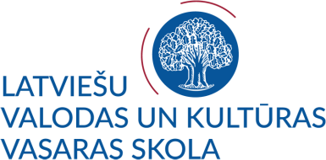
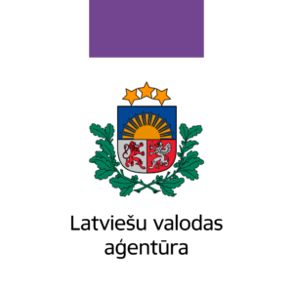
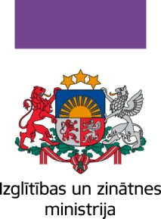

SUMMER SCHOOL OF LATVIAN LANGUAGE AND CULTURE 2019
FOR DIASPORA YOUTH (18-30 year)
with no knowledge of Latvian (A1+)
July 03 – July 16, 2019
For the fifth year, the University of Latvia in collaboration with the Latvian Language Agency organizes "Summer School of Latvian Language and Culture" for students and everyone who wants not only to learn and improve their Latvian language skills, but also to expand their knowledge of Latvian history, art and folklore.

It is the second time the University of Latvia in collaboration with the Latvian Language Agency and the Ministry of Education and Science organizes summer school for diaspora youth. The summer school is funded by the budget programme “State Language Policy and Administration” administered by the Ministry of Education and Science.

We offer:
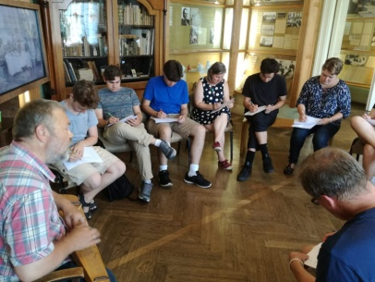
- intensive, modern and interactive Latvian language course (grammar, reading, writing, speaking, 64 academic hours), which includes such topics as human personality, experience, knowledge and skills, friendly contacts and time spent in Latvia, versatile and unique Riga, city tour and orientation, daily life and holidays in Latvia, Latvian traditional and modern culture, current events in Latvian media, Latvia’s and Latvians’ success stories in the world;
- lecture on Latvian history and politics, getting acquainted with modern Latvian history and political situation in Latvia;
- lecture on Latvian culture and art, getting acquainted with its historical development and key figures, especially, in the visual arts and architecture;
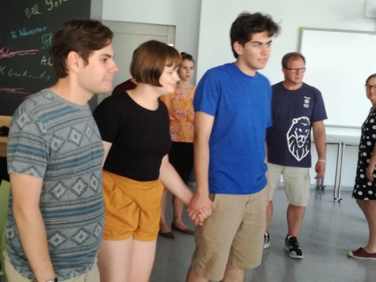
- lecture on Latvian folklore: customs and traditions, getting acquainted with one of the most interesting forms of folklore - Latvian folk songs or dainas, by singing and dancing;
- guided tour of Riga, visiting several museums (e.g., Museum of the History of Riga and Navigation or Museum of the Occupation of Latvia, National Library, Rainis and Aspazija House-Museum in Riga, Latvian National Museum of Art, Latvian Ethnographic Open-Air Museum);
- a two-day trip to port city Ventspils, sightseeing (e.g., Ventspils Crafts House, a boat tour aboard “Duke Jacob” (Hercogs Jēkabs) along the Venta River);
- guided tour to Kuldiga (Venta rapid, old city).

The attendees, having successfully completed the course, are awarded 4 credits (6 ECTS).

APPLICATION FOR SUMMER SCHOOL
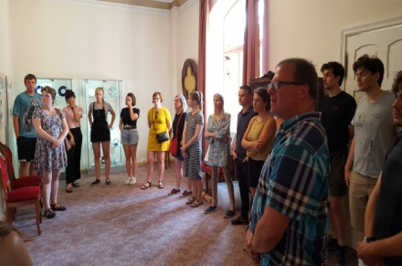
Application deadline 24 April 2019.

Information on the decision taken will be sent to the applicant’s e-mail address by 5 May 2019.

Applicants shall submit their confirmation of the participation in the summer school by e-mail to sagkursi@lu.lv by May 16, 2019.

Documents to be submitted by the citizens of the EU Member States and other countries who do not need a visa:
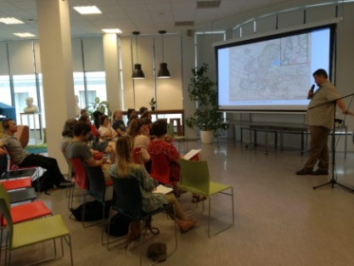

- completed application form for participation in the summer school;
- a letter of motivation

The documents should be sent electronically to the e-mail sagkursi@lu.lv.

Documents to be submitted by the citizens of the countries requiring a visa to enter the EU:
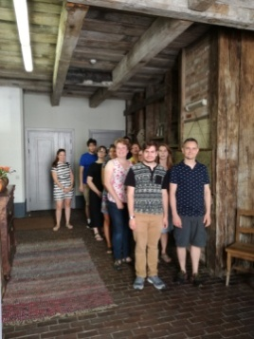
- completed application form for participation in the summer school;
- a letter of motivation (a personal statement);
- statement / confirmation of the university
(shall be submitted only in case the applicant is a student)
- passport or identity card (ID) copy

The documents should be sent electronically to the e-mail sagkursi@lu.lv.

NB: Information for non-EU students.
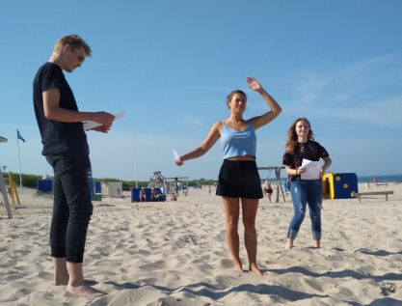
Students are responsible for their visa application and other related arrangements. Summer school organizer does not cover fees for visa services. The University of Latvia helps with visa arrangements only to international students whose higher education establishments have entered bilateral international cooperation agreements with the University of Latvia.

NUMBER OF PLACES
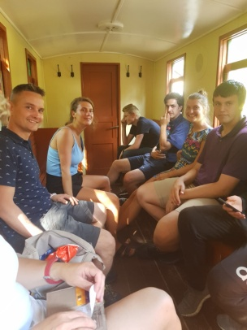
We planned - one group for participants without prior knowledge. The number of participants per group is limited to 13 people.
If the number of candidates exceeds the number of available places, the participants will be selected according to the following criteria:
• timely submitted application;
• all documents submitted;
• participant's motivation.

PARTICIPATION FEE
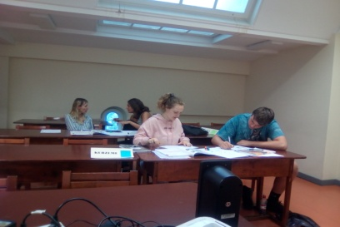
The participation fee is fully covered.
The participation fee does not include accommodation and food in Riga.

The participation fee - covers Latvian language classes, tours, study materials, participation in social and cultural events, a two-day trip to Ventspils (including accommodation, meals).

The participation fee does not cover accommodation and food in Riga.

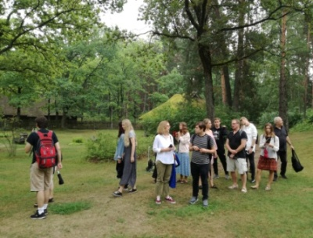
WITHDRAWAL POLICY
If you want to cancel your participation, inform the summer school organizers in writing by sending an e-mail to sagkursi@lu.lv by 24 May 2019.

ACCOMMODATION

Other summer school participants are offered accommodation in Riga at a surcharge:
UL Dormitories (detailed information is available on the website of the University of Latvia):
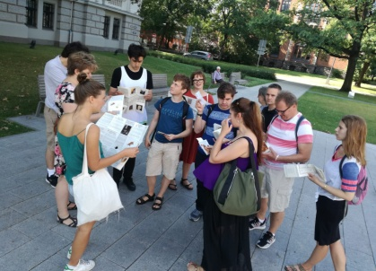
- Hostel (Riga, Reznas street 10C), a single bed (common kitchen area and a
shared bathroom):
  - in a triple room € 5.00 per night
  - in a double room € 8.00 per night

INFORMATION
More information about the summer school, fees, program, application procedure is available at the UL website:
http://www.latvianlanguage.lu.lv/

CONTACT US:
Sarmite Miltiņa phone (+ 371) 67034892, mob. phone (+ 371) 20279199, sarmite.miltina@lu.lv

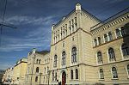
Agnese Sipjagova, as13246@lu.lv

Pre-Studies Training Centre of the University of Latvia
Aspazijas blvd 5, room 242,
Riga, LV-1050
Latvia
E-mail: sagkursi@lu.lv, www.lu.lv

